Data Analysis

Student’s Name
Institution Affiliation
Course Code
Professor’s Name
Due Date

Data Analysis
It is how cleaning, transforming and modeling the available data to make and discover all valuable information of all the decision-making that involves businesses and all their operations. Data analysis is essential in extracting all helpful information that would generally be done from the valuable information. It is also done as in the taking of data and all decisions based on the data analysis. The report found in the data analysis generally helps ensure that the decision-making process happens well, hence the firm's success. Data analysis will help in the provision of all which is needed for a good decision-making process.
Cost
It is the entire amount in which a firm spends to enhance the creation and production of goods and services. In the cost, there is not included the markup profit for all which happens in the firm (Bendat et al., 2011). It is generally all the amount of money which is spent on the creation of goods and services.
Month | January | Feb. |  | March | April | May | June | July | Aug. | Sep. | Oct. | Nov. | Dec.
Cost | 23920 | 23920 | 23920 |  | 23920 | 18460 | 18460 | 17095 | 17095 | 17095 | 17095 | 17095 | 17095

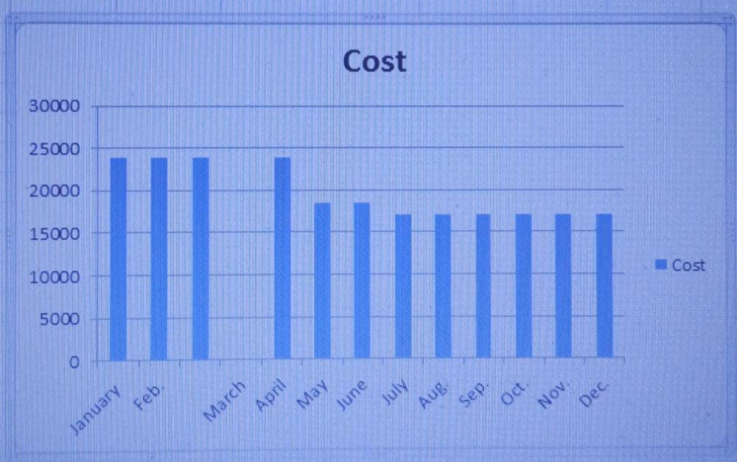
From the data provided, it is clear that the firm for the first four months had a stagnant amount of sales. After April there is a decrease in the costs of all goods sold within the firm. It is good to highlight that the firm led to the increased amount of goods or the remaining months from July, which implies how the management had been leading to many sales.
Revenue
It is all the total amount of income that a firm generally gets from the sale of goods and services for the firm or related to the firm. It appears at the top line of the income statement. It includes discounts and all deductions that are done for returned merchandise.
Month | January | Feb. |  | March | April | May | June | July | Aug. | Sep. | Oct. | Nov. | Dec.
Revenue | 5000 | 7500 | 22500 |  | 12500 | 7500 | 22500 | 22500 | 22500 | 30000 | 22500 | 22500 | 22500

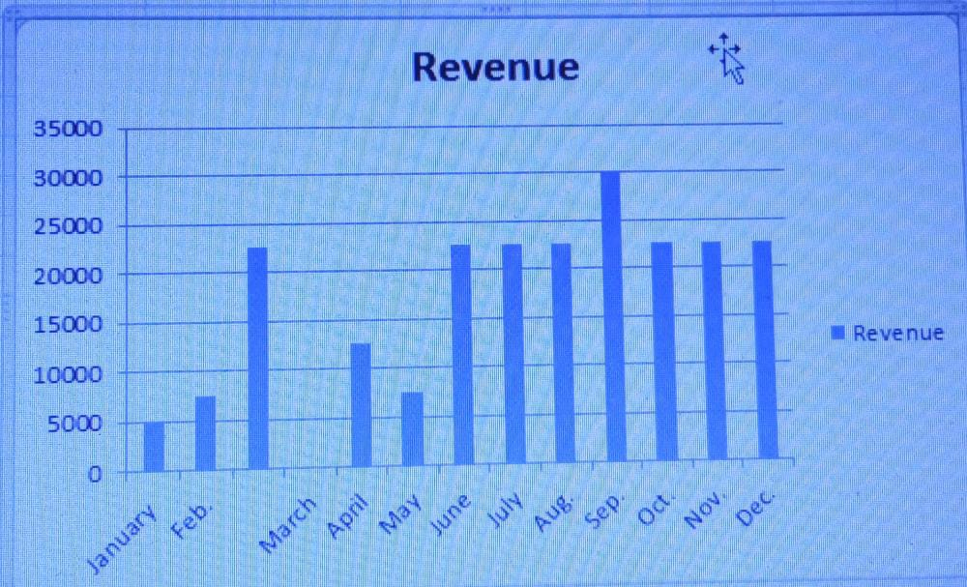
From the data, it is clear to highlight that the firm was ensuring significant revenue from its operations. For January, the firm was getting less income where after proper marketing and all together related issues, the firm was getting all that would be needed to facilitate all its operations (Heeringa et al., 2010).
Profit
Month | January | Feb. |  | March | April | May | June | July | Aug. | Sep. | Oct. | Nov. | Dec.
Profit | -18920 | -21020 | -6020 |  | -16020 | -14510 | 490 | 2117.50 | 4617 | 9617.50 | 9617.50 | 9617.50 | 9617.50

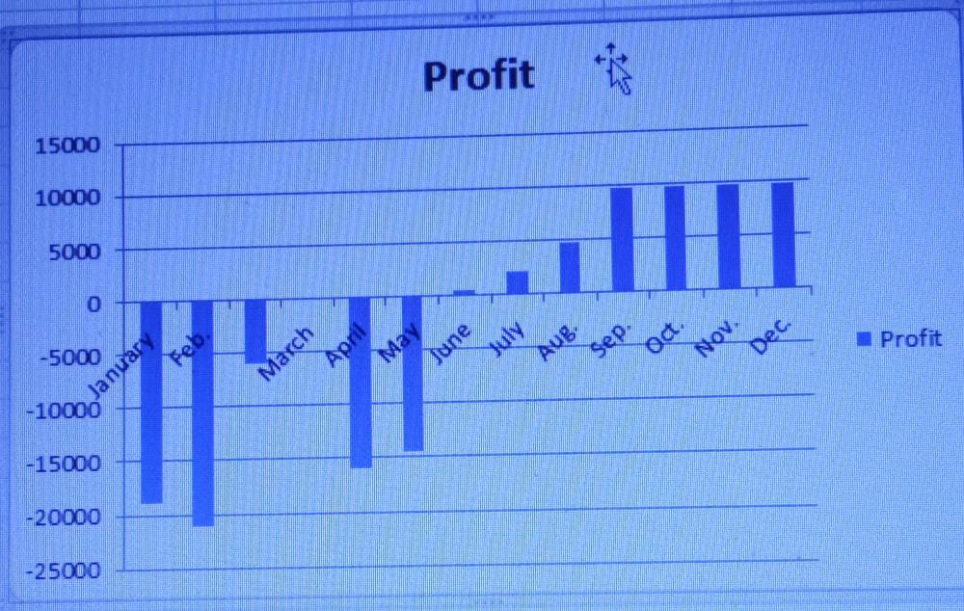

From the data, it would be good to highlight that all the necessary things to do are done and what is done. For the first five months, the firm was operating at a loss. During the rest of the months during the year, the firm was working on profit which made it a good plan in which it generally ensured that the firm recovered from its bad practices that led to losses and now generated profits. For the firm, the percentage profit was 4.18 percent during the year.
Graphic selected
The graphic that was selected to give a clear illustration of the analysis is by use of graphs. The graph was used as a kit shows the relation that generally exists between one month and the other. It will give the management a clear illustration of how all is supposed to happen in the firm. By looking at the graph, one can easily highlight what will occur in the firm next time. The target audience generally does not affect how the data to be represented will be as it only needs a clear illustration of all that needs to happen.

References
Bendat, J. S., & Piersol, A. G. (2011). Random data: analysis and measurement procedures (Vol. 729). John Wiley & Sons.
Heeringa, S. G., West, B. T., & Berglund, P. A. (2010). I applied survey data analysis. Chapman and Hall/CRC.

